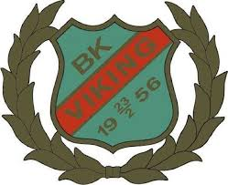

KLUBBVÄRDSCHEMA!

V. 33, 45 Liv Fritzon

V. 34, 46 Siri Sjöström

V. 35, 47 Ester Rubensson

V. 36, 48 Majlis Allsten

V. 37, 49 Lova Liljegren

V. 38, 50 Gry Wennberg

V. 39, 51 Lykke Arvidsson

V. 40, 52 Olivia Persson

V. 41, 1 Teo Jönsson

V. 42, 2 Saga Persson

V. 43, 3 Melker Rosenstråle

V. 44, 4Malte Olsson